Chapter 2, Solution 43

(a) R_{ab} = 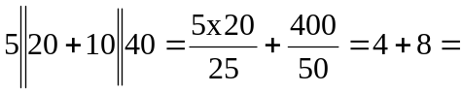 12 Ω

- 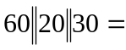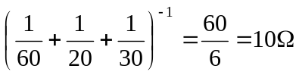

R_{ab} = 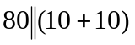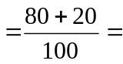 16 Ω

